**Fluffy Easter Bunny**

**Pattern by Benny Buds**

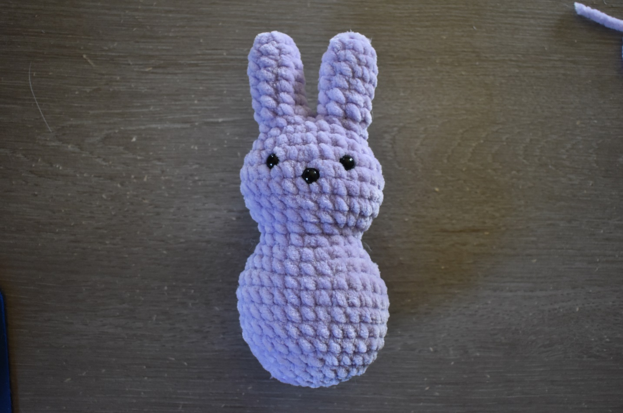

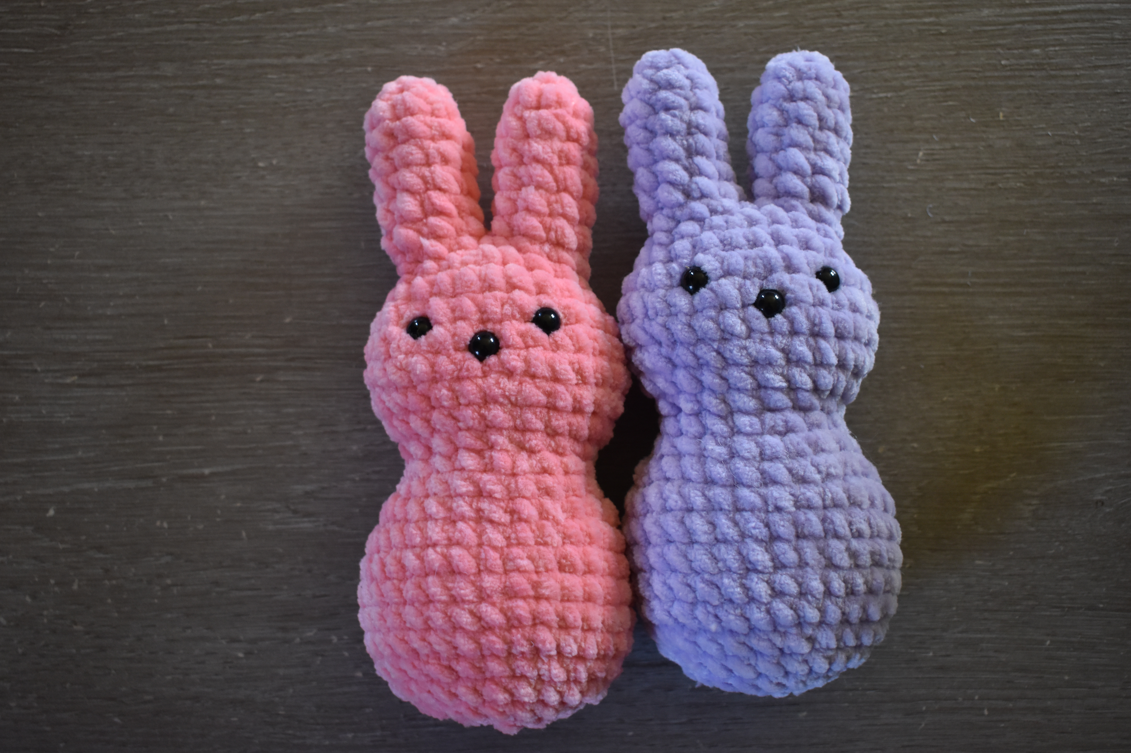

**Materials**

* Premier Parfait Chunky – any color
* 4.5 mm crochet hook
* 3 - 10 mm safety eyes
* Stitch markers
* Scissors
* Stuffing material of your choice

**Crochet Terms/ Abbreviations**

* MR – Magic Ring
* sc – single crochet

**Finished Size**

* Around 7 inches tall if you use similar weight yarn and a 4.5mm crochet hook

**Notes**

* The number inside the parenthesis of each round shows the final count of stiches on that round.
* dec – single crochet decrease
* inc – single crochet increase

**\*\*\*\*This pattern is for personal use only. Please do not copy, share or distribute any portion of the pattern. Pattern made by Benny Buds. You can sell the bunny you made! Just give credit for the pattern to Benny Buds\*\*\*\***

**Ears** (make 2)

R1: 6sc MR (6)

R2: 2sc, inc, 2sc, inc (8)

R3-6: 8sc (8)

R7: 8sc, inc (9), slip stitch

Fasten off 1st ear only.

Continue on 1st ear starting in slip stitch: 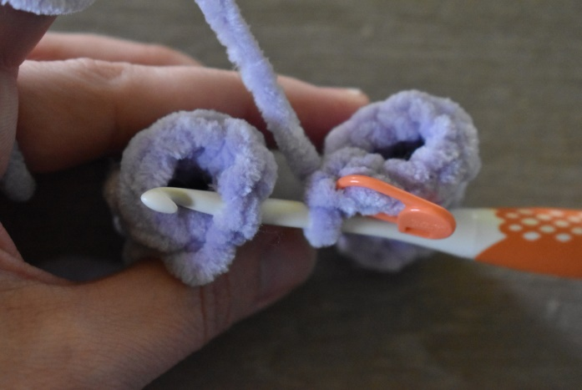

R8: 4sc, dec, 3sc (1st ear) 3sc, dec, 4sc (2nd ear) (16)

(use tail to sew up hole where ears are joined)

R9: (3sc, inc) x4 (20)

R10: 4sc, 3sc in next stitch, 9sc, 3sc in next stitch , 5sc (24)

R11: (3sc, inc) x6 (30)

R12-13: 30sc (30)

R14: (3sc, dec) x6 (24)

*Stuff both ears at this point and add safety eyes*

Eyes are placed between rows 11 and 12, 6 stitches apart.

Nose is centered in the row below.

R15: 4sc, dec, 10sc, dec, 6sc (22)

R16: 1sc, dec x3, 5sc, dec x3, 4sc (16)

R17:*whole round is worked in the front loop only* (3sc, inc) x4 (20)

R18: 2sc, inc, 9sc, inc, 7sc (22)

*Continue to stuff firmly*

R19: 2sc, (3sc in one stitch) x2, 9sc, (3sc in one stitch) x2, 8sc (30)

R20-24: 30 sc (30)

R25: (3sc, dec) x6 (24)

R26: 3sc, dec, 10sc, dec, 7sc (22)

R27: dec x3, 5sc, dec x3, 5sc (16)

*Finish stuffing*

R28: dec x8 (8)

Fasten Off. Weave in ends.

